**Graded Assignment on Docker and CI-CD pipeline**

**Question1 :** You are provided with a ReactJS application and it can be found on the repository with the link provided below.

Create a Dockerfile for this React application and also create image and run the image as container and the output of the ReactJS application should be shown on the localhost.

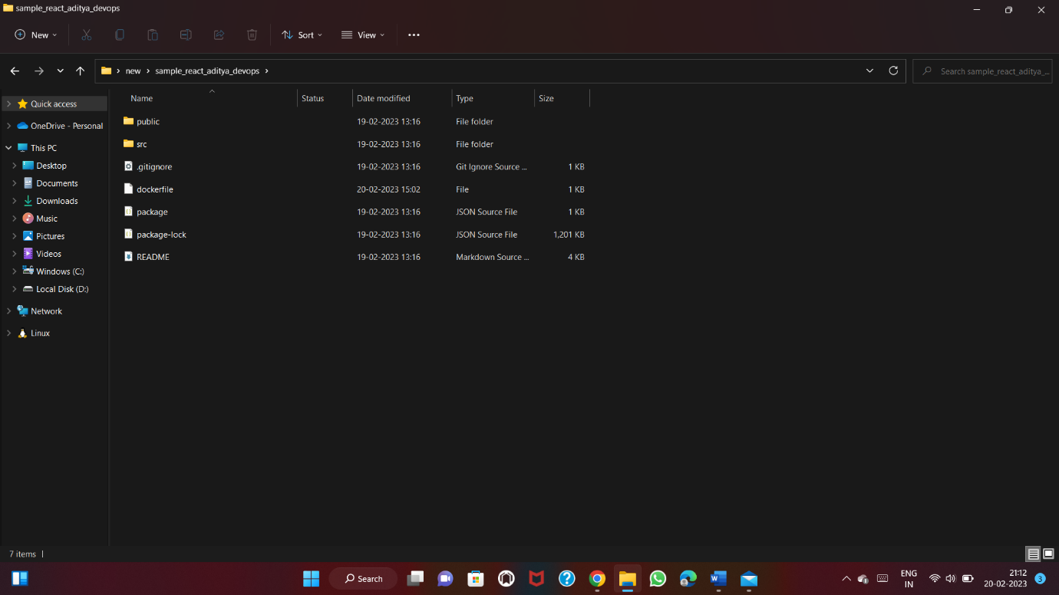

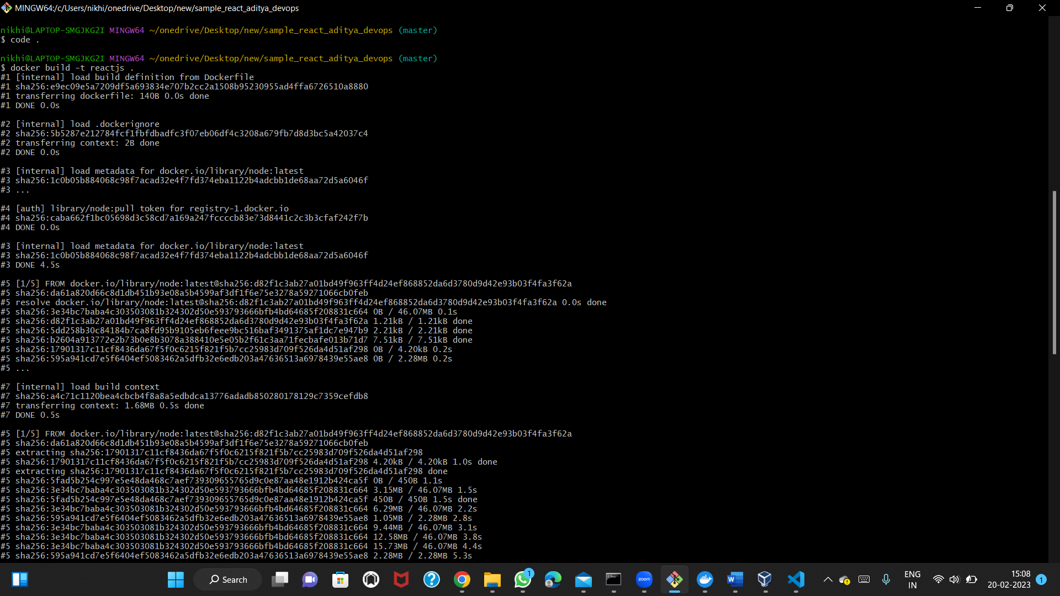

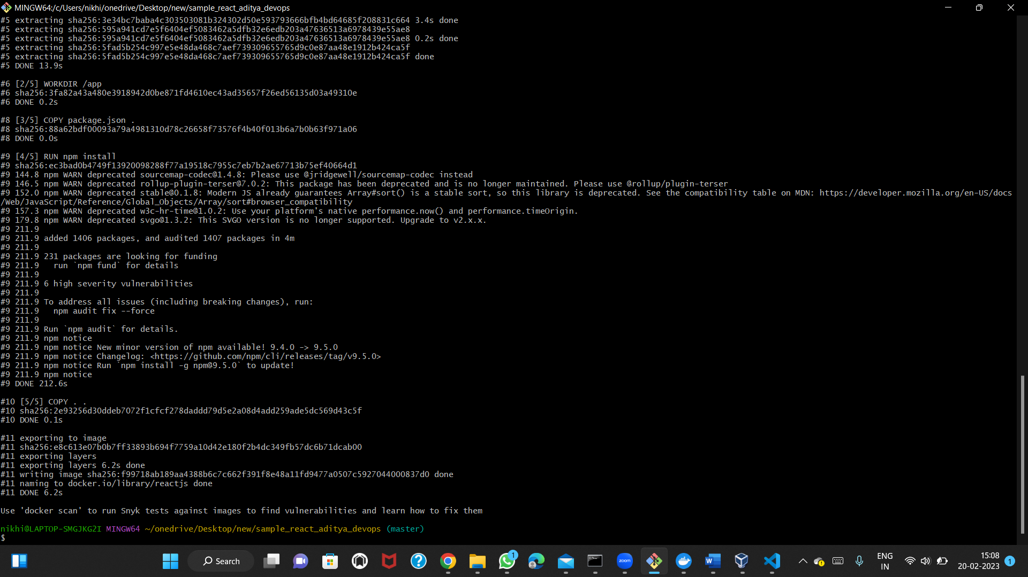

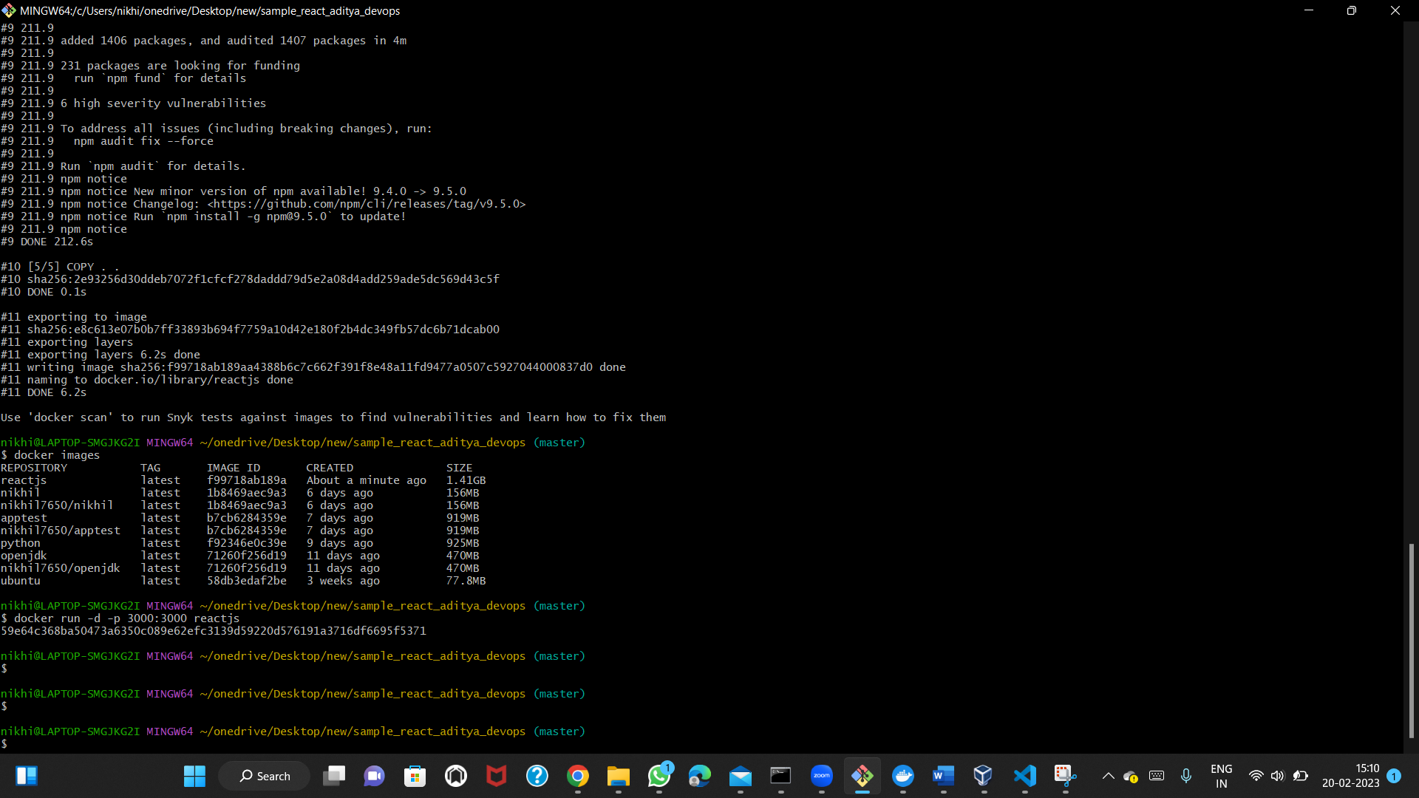

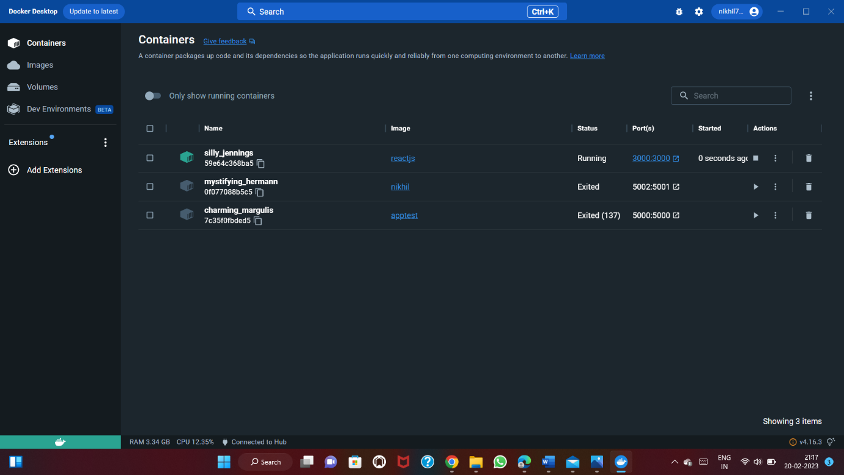

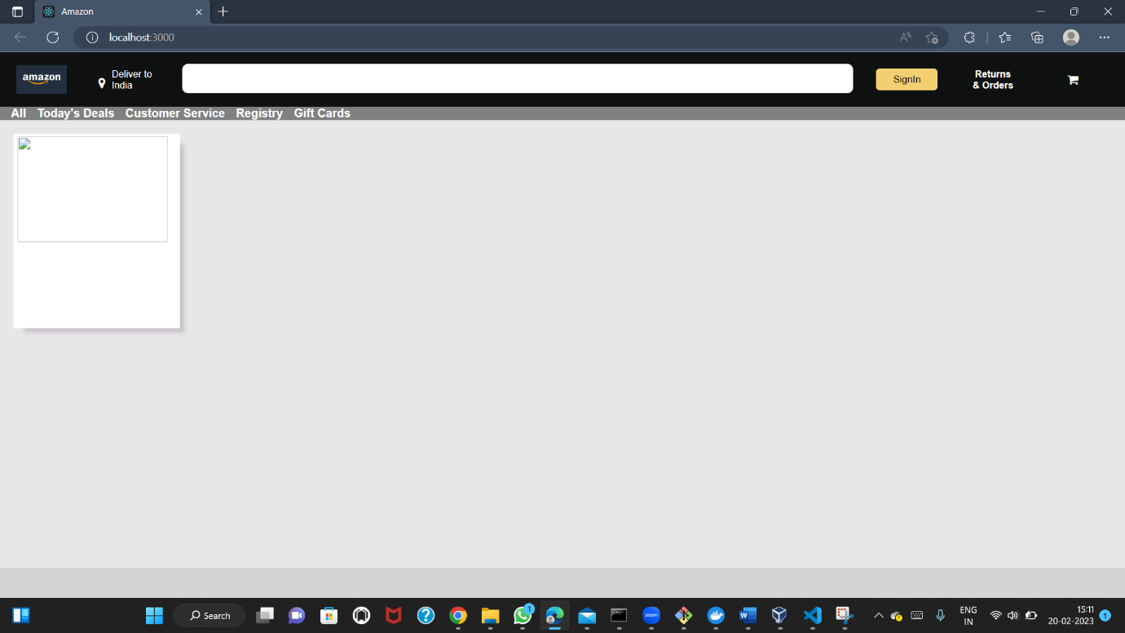

Question 2:

Describe the CI-CD pipeline and also describe the role of jenkins here.

You have to create a manual ci-cd pipeline through bash script and cron jobs for a nodejs simple application. For the Node JS application you can have the same application provided to you on the repository here [:https://github.com/snehal-herovired/LearningGIt.](https://github.com/snehal-herovired/LearningGIt)

CI-CD-PIPELINE:

A continuous integration and continuous deployment pipeline is a series of steps that must be performed in order to deliver a new version of software. CI/CD pipelines are a practice focused on improving software delivery throughout the software development life cycle via automation.

JENKINS:

Jenkins is an open-source automation tool for Continuous Integration (CI) and Continuous

Deployment (CD). It is a server-based system that runs in servlet containers like Apache Tomca.

